Made and Written by Cameron Lee Widmar and Allyn J Koger
- New Game Design
  - Title: Known World Warfare
  - Game Type: Multiplayer, campaign is 2 players, single player or co-op
  - For Xbox, Ps4, and PC
  - Languages: English
  - 7 Modes:
    - Training Grounds (familiarize yourself with the gameplay)
    - Conquest (All out war)
    - Team Deathmatch (Team vs Team)
    - Grand Campaign (Retelling the stories of ancient battles)
    - Siege Assault (1 team attacking, 1 team defending)
    - 1v1 Duel (You vs bot or other player)
    - Gladiator Duels (Everyman for himself)
  - Multiplayer Requirements:
    - 10 maps:
      - The Siege of Alesia (siege map)
      - Pydna (Conquest, TDM map, Grand Campaign)
      - Teutoburg Forest (Historical Battles)
      - Cannae (Historical Battles, Conquest, TDM)
      - Trebia River (Conquest, Historical Battles)
      - Battle of Carrhae (Historical Battles)
      - Marathon (Conquest, Historical Battles)
      - The Siege of Tyre (Siege Assault, Conquest, TDM)
      - The Sacking of Rome (Siege Assault, Conquest, TDM)
      - The Siege of Carthage (Siege Assault, Conquest, TDM, HB)
    - 7 Modes brief descriptions:
      - Training Grounds
        - Familiarize yourself with the gameplay.
      - Conquest
        - Classical all out warfare, capture the command posts.
      - Team Deathmatch
        - Small maps, team versus team, fast paced infantry.
      - Grand Campaign
        - Relive the tell tale stories of the battles of ancient empires.
      - Siege Assault
        - Offense versus defense, large scale mode battles.
      - 1v1 Duel
        - Face off one on one with a bot or a regular player.
      - Gladiator Duels
        - Free for all. Fight, and you just might survive.
    - Squad System (up to 5 players per squad, 6 squads, 30 players per team)
    - Combat attacking system using a weapon (sword, spear, etc.)
      - Light Attack
      - Medium Attack
      - Heavy Attack
      - Executions
      - Combos
    - Combat system attacks part 2:
      - Light attack:
        - Slash right
        - Slash left
        - Uppercut
        - Downwards stab
      - Medium attack:
        - Hilt jab
        - Weapon stab
        - Circular arc wide slash
      - Heavy attack:
        - Heavy stab and shield bash
        - Heavy slash and shield jab
    - Combat attacking system using shield:
      - Shield bash:
        - Bash up (face area)
        - Bash down (bash feet, shins.)
        - Bash left (flip a player off his/her feet)
        - Bash right (flip a player off his/her feet)
        - Bash diagonally left upwards (flip a player in an upwards manner. The enemy class should be rolling through the air.)
        - Bash diagonally right upwards ( flip a player in an upwards manner, the players class should be rolling through the air.)
    - Combat defensive system:
      - Using a shield:
        - Block up
        - Block down
        - Block right
        - Block left
        - Block center of body
    - Amount of troops teams receive for attacks: 50 for a poor attack, 100 for a decent offensive, and 150 for an excellent offensive.
    - 8 main factions that you can play as: Rome, Gaul, Parthia, Macedonia, Greece, Carthage, Germainia, and Persia.
    - Reward system
    - Pre round/Pre match timer
    - Maximum level is 100 for all classes
    - Each time you level up a specific class, you gain increased damage, health and stamina for that specific class
    - Spectator mode
    - Combat system
    - Training grounds
    - Each time that you win a match, you receive a random chest of any color based on your performance
    - Chests rank from common (white), rare (turquoise) epic (dark purple), and legendary (gold)
    - Chest rarity are color coded (white, turquoise, dark purple, and gold)
    - Class Customizat
    - Command Wheel
    - War cards
    - Unit Customization (different from class customization)
    - Denarii will be the currency of the game and as a bonus reward for winning matches, daily chest, etc.
    - Unlocking abilities/equipment
    - Upgrading equipment/abilities
    - Unlocking slots for your units (both campaign and multiplayer)
    - Winning team receives rewards, aka chest, denarii, class xp, unit xp.
    - Currency in the game is denarii, which can be used to unlock and upgrade your characters armor and equipment
    - Mini Map (map will be based on/by radar)
    - 4 soldier classes
    - Combat roll (infinite)
    - Skill point system for upgrading your characters
      - Assault (Run & Kill):
        - Equipment: Sword, shield, spear, helmet, body armor, shoes, (depending on the faction and that era, greaves.
        - Abilities:
          - Spear Throw: You toss your spear at the enemy, dealing damage.
          - Furious Rage: You receive a damage bonus for the next 30 seconds.
        - War Cards(for all classes):
          - Juggernaut: You increase your damage by 20 points.
          - Unrelenting: You take less damage from explosive missiles and other weapons.
          - Quick Regeneration: Your abilities, health and war cards accelerate their regeneration process.
          - Health boost: Your health increases from its original, to an additional 50 health each time you upgrade this war card.
      - Heavy (Tank, can take out hordes of enemies)
        - Equipment: Heavy weapon/blunt weapon, armor, shield,
        - Abilities:
          - Unstoppable anger: You go into a rage, and you increase your critical damage per hit for the next 30 seconds.
          - Shield bash: You slam your shield into someone, breaking their guard, and dealing a small amount of damage.
          - Unlimited Power: Your weapons have increased damage, you have increased health, and your armour cannot be penetrated for the next 30 seconds.
          - Cavalry (Support/shock unit)
        - Abilities:
          - Wedge charge: You are able to unleash a devastating charge into the enemy ranks.
          - Dismount: You are able to dismount and fight on the ground. This ability will recharge faster because you will often find that you will fight on both horseback and ground.
          - Devastating Slam: Your horse will rear up and slam its hooves into the ground, killing an enemy soldier.
        - Archer (support)
        - Abilities:
          - Multi shot: This ability allows you to shoot three arrows at once. This ability does more damage, but it will drain your ammunition faster.
          - Quick reload: You are able to reload your bow quicker by 5 %.
          - Flaming shot: This ability allows you to set your arrowhead on fire. It deals more damage, but is reduced in accuracy when shot.
        - How ammunition works for this class: You are able to have a total of 100 arrows in your quiver.
  - Multiplayer: Multiplayer is not open world, it will be like most multiplayer games online. That being said, multiplayer will be massive. Now let's talk about conquest:
  - Conquest: Conquest is going to be a little different than the past games of conquest in other games. This conquest involves capturing command flags and killing players, using siege equipment to your teams advantage, and then finally, there are 2 phases, the Conquest Phase, and the Final Stand Phase. You can also spawn on the conquest flags, as well as your own squadmates.There are 2 phases in which conquest is fought. The very beginning will be the capturing of command points and killing players to get points toward the next phase. This phase is called the conquest phase. (each time a player dies, that is one point towards the other team. Bots do not count as points, but will add to your score and your XP). There will be siege equipment to help out each team. Each time a team captures a command flag, there will be a catapult and a bot will spawn with it to fire the catapult (you can also fire the catapult, along with its alternate firing mode, which will be called “Flaming Shot.” Flaming Shot allows you to set the boulder on fire. The fire will deal more damage but has reduced accuracy when launched. Each team has an original spawn point, which will be a fortress. You can spawn on the original spawn point at the beginning of the game. You will also have a squad that you can choose. The conquest mode can have a total of 30 players per team, which makes a total of 60 players per match. That being said, there will be 6 squads for each team, and each squad can hold a total of 5 players, There are 6 conquest points that they could capture. The squad points are named as such: A, B, C, D, E, F. There will also be ability and war cards for each of the classes, and you can customize your soldier exactly the way you want. You can have a total of 4 ability cards equipped. So after one team reaches a grand total of 1,000 capture points, the other team gets reinforced with extra troops, extra defensive siege equipment. This is when the team that is losing, is at their strongest. There are 2 phases in conquest. They are called the Conquest Phase, and the Final Stand Phase. The Final Stand. If the attackers lose, or are unable to complete this phase, they break the siege, and everything returns to the conquest phase again. During this phase, the attacking team will be reinforced with a battering ram, troop reinforcements, and other siege equipment(ladders, catapults, and siege towers). The defenders will be reinforced with a commander and siege defense equipment, aka catapults, hot burning lava that pours onto the soldiers who are trying to break through the gate, and ballistas that the players and AI can man/equip. If the attackers are able to penetrate the citadel's walls and break into the city, the defenders will be pushed back. The defenders will have 3 sectors that need to be defended. That is the main level, upper level, and the top level. Each team, at the beginning of the conquest round, has a total of 450 troop lives. There are 3 phases. The Conquest Phase, and the Final Stand Phase. Each time they complete a phase, they get player lives, depending on their performance, they could get 50, 100, or 150. The first section is defending the walls and the gate, aka the Outer Defences. The 2nd section is defending the town square, and the third section is defending the Keep. The Final Stand Phase begins with the Outer Defences. This will be included in capturing either the gate, or the both the east wall and the west wall. Once captured, the attackers can advance to the next section. 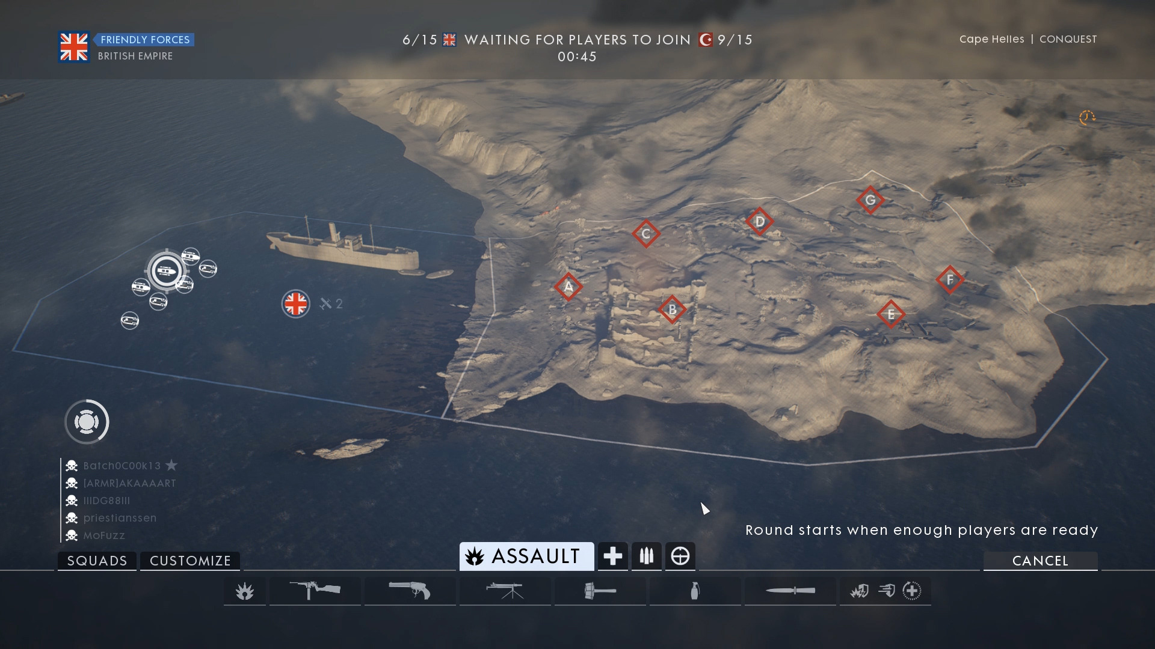
    - Each team will switch sides in order to complete a match (there are 2 rounds, that make a match). Here is a possible example of the original spawn point (the British insignia) and the conquest capture points. So basically the original spawn points are a citadel or a fortress, or an encampment. Here in this picture is also an example of how the classes could be designed, and what the loadout could be for each class. At the end of each round, your score will be assessed, and you will receive units for the faction war, gold to upgrade your units a skill point for each time you level up that specific class, you get 2 skill points. Each class has ability cards as well. Those ability cards can be used throughout the game, but only once, before they have to recharge. Like in Star Wars Battlefront 2, each star card has to be recharged in order to be used once again. 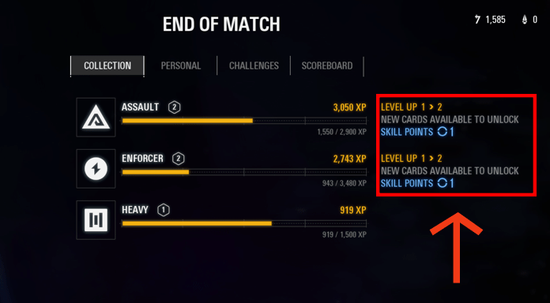
- Here is an example of how the end of the round stats could be for the game. You have the classes progression, then at the top, you have your personal score, then you could have weekly and daily challenges, and then finally the scoreboard. You also have skill points that were gained from leveling up that specific class. Also, when you choose a class, when you die, you can choose a different class. Like in the picture above, the individual that played Star Wars Battlefront 2 did not just focus on one class, but several. The classes that you play as will list a total of 5 per round, and an extra class that you played as will be listed as extra on the bottom, with the XP listed with that class. Then the process starts all over again, and each team switches sides. That's pretty much how conquest should be played in this game.
- Siege Assault: This game mode consists of two teams, one of which is defending, the other is attacking. Each team has up to six squads and can place a total of ten players in each squad. That being said, there will be a total of 60 players per team. Each team will also have bots, siege equipment to help them with defending or attacking. For example, if I was a Roman at the siege of Alesia, then I will have catapults, and other siege equipment that the Romans had to help both defend and attack the Gauls. So each team will have a starting point/original spawn point like in conquest. So each citadel/fortress has a large conquest point, and within that conquest point, there are smaller sections that the attacking team needs to attack and that the defending team needs to defend. For example, at the siege of Alesia, there will be an objective. Within that objective, there will be 3 sections that you need to attack and control for 4 minutes. The control point will be a flag with a flagpole, and the flag will signify the team that you play for. There are three sections which need to be captured and held for 4 minutes. There are three sections( the objective will be called, capture the sector, the sector will be the what you are trying to capture, which could be for phase 1, the gateway, the courtyard, and the walls. If the defenders can hold the attackers back for 10 minutes and have all conquest points under their control by the end of that time, then they win the round, and then the teams switch sides. If the attackers are able to capture all three points, and successfully hold them for 4 minutes, then the next objective starts. The defending team must retreat to the second layer within a minute. If they are killed, then there is no penalty, they just die and respawn on a teammate or on one of their conquest points. The attackers also must wait until the defending team can set up a decent defense at the next level (there will be a border line that will separate the attackers from the defenders, but when all the defenders are at their next objective, then the borderline will be removed, and the onslaught will begin again). Then after the defensive team can get all of its players up to the next level, the attackers can then press up and attack their next objective. If the attackers are able to complete all phases of attack, then the defenders must retreat to the very last phase, which for the attackers, they must kill the commander, and the defenders must defend their commander. If the attackers kill the commander, they win. If they don't, they lose. The attacking team has a total of 200 lives in order to kill the commander. If team loses all of its 200 lives, then they lose. If they kill the commander, they win. During each phase of each siege, each attacking team starts out with 300 lives. Each time they complete a phase, they gain 50 lives. Again, a phase consists of capturing and holding the command posts (around a total of 3 command posts for a total of one minute. Each time that you are capturing a post, it will say securing. This will go on for a full minute. If contested by another player or something, then the icon will say contested). 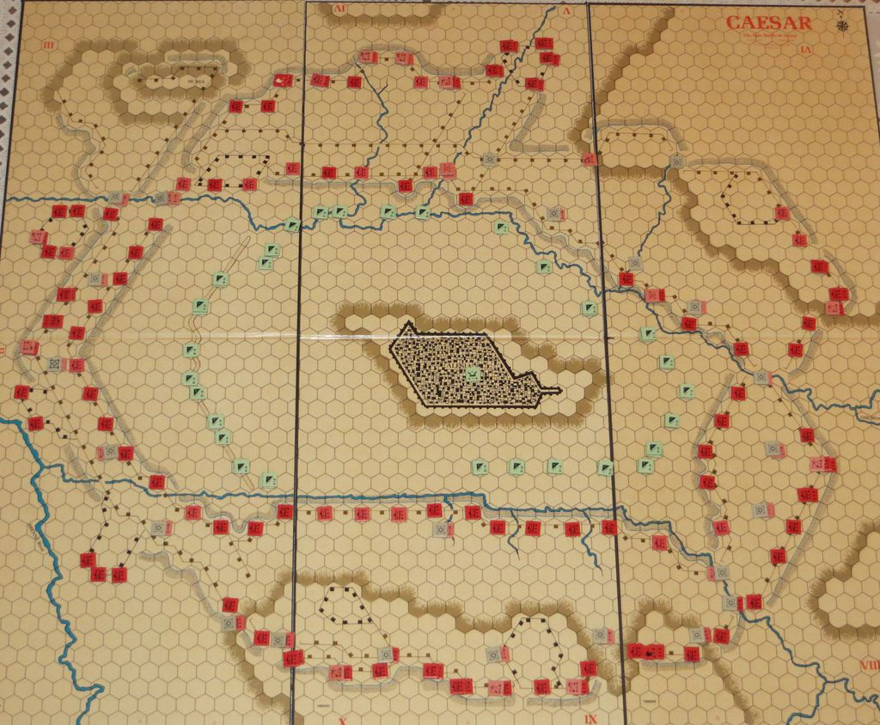

- Here is a good possible example for an overlay map for the siege of Alesia. You have the overlay of the entire city, the Roman forces, and the Gallic forces trapped inside(there will also be a relief force on the outside of the Roman palisades on the left side). Your teammates will be running around in the color red, and you will be able to spawn on them. Each of the conquest points will be the wall, the gate, and the courtyard of the outer ring (it will just be called the courtyard). If an enemy is spotted, then they will show up red for the defending team, and vise versa if you are on the attacking team. Also on the map, you have the large circles outside of the city. These large circles are original spawn points that you can spawn on. You will have a total of six of these circles, so each squad will spawn on one of these circles (be mindful, that the squads do not have to be full up to ten players to be able to spawn on these points. You can spawn individually on these points). Each of these circles is where a unit of bots are placed. Each team has a total of 1,000 bots on their team. There will be two original spawn points on each side of the citadel, and then two spawn points in the center where the gate is. Like said before, each squad is assigned to a specific area that they must capture. And it is the same for the defenders. Instead of having large circles as this map has, they will spawn on the command posts or their original spawn point. Command posts will be signified as the factions flag. Also, the attacking team has a battering ram, one siege tower for each squad and three individual siege ladders for each squad, and the defending has a two catapults/trebuchets, as well as the defenders can equip an explosive mode for the catapults for each command post. The explosive mode allows the defenders to deal more damage to the attackers, but at the cost of less accuracy. (just like the catapult firing mode in conquest) The explosion part is where they ignite the boulder with flame and a satchel bomb attached to the boulder. Therefore the boulder will explode on impact. If the attackers are able to reach a catapult and they want to disarm it, they have to “sabotage” it. This means that they have to press a certain button, and their class will attack a torch to it and set it ablaze. Also, just in case if they are shot at, they will able to put their shield on the left or right side of them, so that they are not shot at. It will take a total of 5 seconds to completely sabotage the catapult. The defending team will have. Each team also has 2 reinforcement classes. That being said, that's pretty much siege assault.
- Character customization: (pictures of characters, possible abilities, and how to customize them): Character customization will also play a very important part in the game. The game will also not be era-specific for the customization of the classes. You will be able to unlock abilities through skill points. You will also be able to unlock emotes, purchase and upgrade your armor through gold that you earn throughout playing multiplayer. But you can only equip equipment at the level that you are at. For example, you can equip a level 50 chest plate if you are that level, but not if you are lower than level 50. Basically, if the level of the equipment is higher than the level of your character, you cannot equip that equipment. You can also sell equipment to receive gold. Depending on the type of equipment (common, rare, epic, extraordinary, and legendary) the equipment will give you a certain amount of gold. Common will give you 1,000, rare 5,000 gold, epic, 10,000 gold, extraordinary, 20,000 gold, and legendary 40,000 gold. That’s for selling equipment. For the actual character customization, as I had said before, the maps will play randomly, and the characters will be based on era based maps. Each character will have the ability to be customized, and each class will start out with regular equipment for online/multiplayer gameplay. For offline gameplay, you will be able to customize your class however you like. Also for offline gameplay, each of the game modes listed above will be playable. Each class, as said before has ability cards, and for offline gameplay, you will be able to have the fully upgraded set, not like in multiplayer in which you have to upgrade your class by playing as that character in online matches. Back to online, you will be able to upgrade the hilt of your weapon, the character itself will be able to be customized. There will be a color will in which you can choose what color you want your character to be, you can customize his shield, you can put emblems on it (like the white hand of Saruman). This will be done in the character customization section. This will be called soldier customization. There will be a specific section for the game modes themselves, but that is to be discussed later in the pages.
  - Team Deathmatch: Each side will have a total of 60 players, 20 of which are
    - assigned to each faction. Each faction will have at least 1,000 bots, and 20 players. The side that eliminates all of the enemy players and each factions army, or routes them and kills all of the enemy players, that team wins the round. Then they switch sides. Each team will have a starting side, the maps will be generated randomly, and there will be a pre-match timer of 60 seconds. Again during that time, you will have the time to customize your soldier and prepare him for battle. Once the battle starts, each faction has an army that they will be facing. It doesn’t matter what faction is facing whom. The orcs could be facing the elves, the orcs could be facing the dwarves, it doesn’t matter which faction is facing another faction. The battlefield is divided up into three sectors. The left, the middle and the right. If the orcs are able to route the elves, the left side opens up, and the orcs can attack the flank of the dwarves (A lot like clash royale, where if you are able to destroy a princess castle, the enemy team loses ground and you can attack the king. It’s the same for this mode). Once your team beats both of the armies on the right and the left side and the middle, you win that round, and then the teams switch sides. Kills will add up to your score, and each time that you kill a player, you receive xp, and it is the same for killing a bot, and the xp you receive is the same. Each side will also receive a bonus for winning the round. The bonus will be money and a piece of a rare equipment, as well as one skill point for each class.
  - Historical battles: Historical battles are based on battles that has happened in the past, and you can play as one of the two factions. For example, let's say you are playing as the Romans in the battle of Alesia, in 52 B.C. As the Romans in this battle, you are supposed to stop the gallic relief force from breaking the Roman siege and saving the civilians and military forces of Vercingetorix. But if you are playing as the gauls, you are going to start out as the forces under the command of Vercingetorix. Each team that wins a match will receive a bonus award. I will be listing of the historical battles in this mode, as well as the factions that you can play as.
    - The battle of Alesia (Rome and Gaul)
    - The battle of Marathon (Greece and Persia)
    - The battle of Salamis (Greece and Persia)
    - The battle of Cannae (Rome and Carthage)
    - The battle of Trebia (Rome and Carthage)
    - The battle of Thermopylae (Greece and Persia)
    - The battle of Aquae Sextae (Rome and Germanic Tribes)
    - These battles will rotate, and they will rotate in chronological order. Each battle will have an intro before you enter the battlefield. The narrator of the battle will tell the story. This is how the narrator will tell the battles story in order:
    - Tell who the armies that are facing each other
    - Explain to each team their objectives
    - Finally, the general will give a speech before the battle(like all of the total war series), and then the battle will happen.
  - Historical battles phases will depend on the battles, a battle could have four phases, or it could have 2 phases. But it will not have one giant phase. I will be explaining each battle in detail below, the phases, the factions that play, and the possible rewards and options.
    - The Siege of Alesia: was against two main powers, which were the Gauls and the Romans. Now this battle will determine whether the Romans will survive and the Gallic empire will die out, or the Romans will fail and their empire will crumple. So now I will be talking about the phases of the battle in the next paragraph
    - 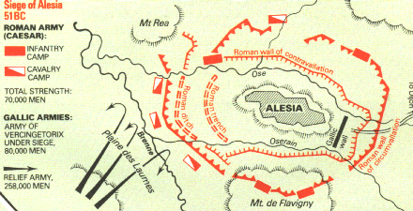
    - So if you are on the Roman side, you will be besieging the Gauls, in there fortress, as well as defending from the relief force that will come to save Vercingetorix. The first phase will be sieging the city of Alesia, where you will be fighting on the walls of the city, trying to breach the city, as well as the gates of the city. If you are able to breach the city, the next phase is that the Roman Army will fall back to their walls because the army needs to fall back in order to protect itself from the relief army coming to save the Gauls in the city of alesia. If you are able to successfully defend against the invasions on both the wall and on the fields(only the cavalry will be on the field fighting and charging the relief army), than you will go to the third phase, which is to recapture the city. Within capturing the city, there will be three main sections in which the Roman army must capture the city. There is the east and the west wall, and then there is the gate. In order to enter the city, the Romans must either capture both the sections on the walls, or they must capture the gate. The gate will be a lot harder because it is one section. Also, each time you complete a phase successfully, the attacking team gains the amount of troops stated on page one, depending on how well they attacked and captured the phase and its sections/objectives. Also there will be bots that will help out with the battles. The amount of bots will also be determined on how well you perform the attacks. In the first phase, the attacking team will start out with a total of 300 lives, and they have to conquer the sections with the amount of lives. If they don't, the round is over, and each team switches sides for the next round. If they are able to capture the city walls, they move onto the next phase of the battle, which will be called, Defend the walls. The objective will be to defend the walls and the gates of the wooden palisades of Caesars walls. For the Gauls, the objective will be Attack the forces of Caesar. If the Romans manage to defend themselves for the next 10 minutes against the Gallic Relief Force, than they move onto the final phase of this battle, which will be called, Capture the fort and defeat Vercingetorix. In the following bullet points, I will talk about The phases, the order that they will be played in, and the forces involved.
      - Roman side objectives (victory and defeat):
        - Phase 1: Break the defense of the Gallic forces inside Alesia.
        - Phase 2: Make a tactical retreat and defend the walls of the palisades against the Gallic Relief Force.
        - Phase 3: Capture the city of Alesia.
      - Gallic Side objectives (victory and defeat):
        - Phase 1: Defend the walls against the Roman forces.
        - Phase 2: Support the Gallic Relief Force by attacking the Roman forces.
        - Phase 3: Defend the walls of the city, if the gallic relief force fails to defeat the Roman forces.
      - Roman Phase names:
        - Capture the walls and the gate house of Alesia
        - Defend the walls of the palisades
        - Capture the city of Alesia and kill Vercingetorix
      - Gallic Phase names:
        - Defend the walls and the gatehouse from the Roman forces
        - Capture and hold the walls of the palisades
        - If failed to do so, retreat and defend the city
    - The battle of Marathon: The battle of marathon was a battle between the greeks and the persians 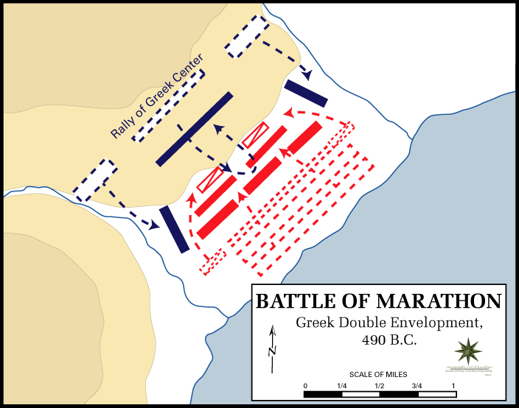
  - The battle of marathon will have a total of 3 phases. I will be describing the phases and the battle in the next few paragraphs. Phase 1 for the greeks will include a surprise attack at the top of the hill, in which the greeks will charge downwards onto the tired persians who are setting up camp. So basically, the first phase is when the greeks will charge downwards to the persians. The second phase is when you will clash with the persians. For the next ten minutes, your objective is to kill as many persians as you can. (obviously, there will be a respawn if you die). After the ten minutes, the next phase comes up. There will be a small cutscene where it will show the persians make a small breakthrough in the line of the greek army. The third phase is after the cutscene, you will make a tactical retreat to the top of the hill, and your army will attack both the middle of the persian army and the sides of the persian army. Again, for the next ten minutes, you need to defend against the persian army. If they persian army is able to kill a total of 200 of your soldiers, than they win the game. If you are able to defend yourself against the persian army, than the 4th phase will begin. Again you will charge down the hill, as the persians are retreating towards their ships. You need to kill as many persians as you can before they make it to their ships. After they make it to their ships, the match will be over, and the greeks will have won that match. I will be describing the phases and how they will be played and their order below in bullet points.
      - Greek Phases
        - Phase 1: The greeks will charge down the hill at the persians.
        - Phase 2: The greeks and persians will be in a stalemate. For the next ten minutes, the greeks have to kill as many persians as they can.
        - Phase 3: The Persians will break through the lines of the greeks(small cutscene) and you will need to make a tactical retreat to the top of the hill. At the top, you will need to defend against the persians for the next 10 minutes. The amount of persians that the player kills will contribute to your score.
        - Phase 4: There will be a small cutscene in which after you successfully defend yourself against the persians. After the cutscene, your army will again be able to charge down the hill, and attack and kill as many retreating persians as possible.
      - Persian Phases:
        - Phase 1: You need to attack at the greeks that are charging down the hill at you.
        - Phase 2: As you are in the stalemate with the greeks, you need to kill a total of 100 greeks as a team in order to break the greek line of attack.
        - Phase 3: If you manage to break the greek line, you will need to press forward the retreating greeks. There at the top of the hill, you will need to kill a total of 200 greeks in order to break there line of defense. At that point, the match will be over.
        - Phase 4: If you as the persian team are unsuccessful, you will need to retreat to the boats. If you die as a player while you are retreating, you will not be able to respawn
    - The battle of Cannae: The battle of Cannae was between the Romans and the Carthaginians. This battle was one , if not one, the greatest roman defeat ever in history. I will be outlining the phases and the tactical map below in which this map will be played. 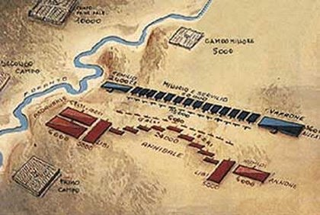
    - On this map you will see that the Romans are in blue and that the Carthaginians are in red. In the next bullet points I will define the battle itself, who played, and the phases.
      - Roman Phases:
        - Phase 1: You will be in the center of the formation, (unless you decide to choose cavalry as your class) attacking the Carthaginian center.
        - Phase 2: As you attack the carthaginian center, you need to kill a total of 200 carthaginians in the center.
          - If you are a cavalryman, you will need to kill a total of 75 carthaginians. Than the carthaginian cavalry will fall back so that you can now attack the flanks of the center.
        - Phase 3: After phase 2 is completed, than you will have to do a tactical retreat, back to your formation. There, the carthaginians will be attacking you up on a hill. On the hill, you will be attacked through 3 attempts. At each attempt, if the carthaginians fail to kill 200 of your men, the next attempt will happen, and again, the carthaginians will need to kill 200 Romans again. Repeat for the third attempt. If the carthaginians break your line of defense, then you will retreat back to your camp, and you need to defend the commander or his bodyguard. If you are able to defend against these attacks for the next 20 minutes, than you win the match. If not, you will lose the match.
      - Carthaginian Phases:
        - Phase 1: You need to hold off the Roman attackers in the center from attacking for the next ten minutes. If you are cavalry, you will need to defeat 75 roman Cavalry.
        - Phase 2: After the ten minutes, you will need to kill a total of 200 Romans in order to advance to the next phase.
        - Phase 3: The Romans will be retreating to a top of a hill. You will need to kill a total of 200 Romans in order to attack their camp and kill the commander or his entire body guard.
  - 1v1 Duel: Now I will be explaining about 1v1 duel game mode. This game mode in particular will focus on your skills and your ability to fight. There are two options in this game mode. They are fighting bots, or you will fight a regular player. You cannot choose to fight a player until you have gained rank 5 in the 1v1 duel. Ranks can be advanced through really quickly if you are able to defeat your opponent. There will also be rewards in which you can receive if you defeat your enemy within a certain number of minutes. Also, you can get a bonus reward if you finish the 1v1 duel if you have your health above 50% by the time the match ends. I will describe down below the possible rewards you can get and as the characters you can play as:
    - Characters:

Retiarius

Secutor

Murmillo
      - Dimachaerus
    - These characters above are the four that can be played as. You will have a pre match timer before you start the match. When you enter the arena, there will be a quick intro before you will start. Once you start, you will have ten minutes to kill the deplete the enemies health. Once you deplete the enemies health, there will be a short cutscene, showing the emperor saying thumbs down. You will then perform an execution move. But the guy on the ground will have a chance to escape. If he does, he will gain half of his health, and all of his stamina back. If not, well he dies than. You will get a reward for winning the duel. That reward will be 2,000 gold, as well as fame and xp for your rank in the arena. That's basically 1v1 duels.
    - Gladiator Duels: It's free for all in the arena. You can get killed by lions, traps, gladiators, etc. The last man standing wins. The reward is 3,000 gold, xp and fame. You will be able to fight both gladiators, and animals. The last man standing wins. If you die, there will be no respawns. In the arena, there will be a total of 32 players. There are three arenas in which you can advance to. They are the Mud Pit, the Bloody Arena, and the Coliseum. You will be able to fight animals in the Bloody Arena and the Coliseum, not the Mud Pit. Once it is the last 2 surviving gladiators, you will need to kill the enemy player. If you manage to kill the enemy player, you will win. There will be a small cutscene after you kill the enemy, showing the emperor throwing a thumbs down. You will then perform an execution, and kill the player. You can advance arenas by killing players, winning fame, and winning matches. You can advance arenas when you level up 5 times. You can reach a max level of 50.. Each time you advance levels, your damage, health, and stamina increases (this is for all game modes and characters). You can apply skill points as well. You gain a skill point each 2 levels. And that is pretty much it for Gladiator Duels.

